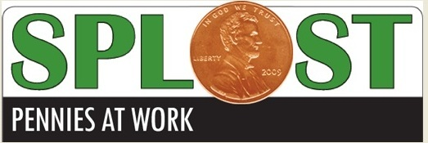

**SPLOST to be voted on November 7, 2017**

The Board of Commissioners have approved the final documents calling for a referendum to continue SPLOST. (Special purpose local option sales tax).

This project will be voted on - November 7th. The SPLOST estimated revenue will begin April 1, 2018 and continue over the next 6 years generating $5,000,000.00.

Sales tax pennies collected will be disbursed as indicated in the chart below...

