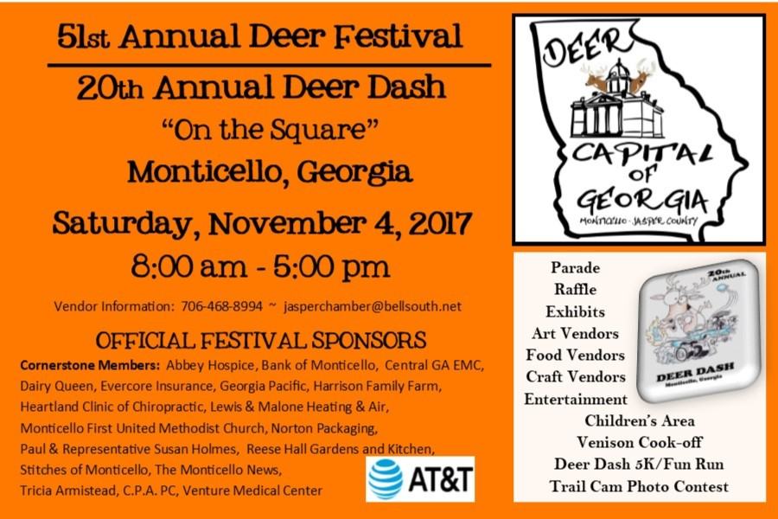

**51st Annual Deer Festival of Jasper County - November 4, 2017 -** sponsored by Monticello-Jasper County Chamber of Commerce. The festival will be held in tradition on the Square in Monticello, Georgia on November 4, 2017. The annual festivities will begin with the award-winning **20th Annual Deer Dash – 5k walk/run and 1 miles fun walk/fun**. The day’s events are from 7:30 am to 5 pm with something for all ages to enjoy.

The Deer Festival began in 1966 and was organized by the Jasper County Jaycees. The Jasper County Chamber of Commerce began organizing it in 1997. The annual festival was created to celebrate the county’s designation as “The Deer Capital” of Georgia. This year’s theme reflects the designation Deer Capital of Georgia.

The **festival t-shirt** which is now available for sale in the Visitors’ Center ($20.00 long sleeve and $15.00 short sleeve) is safety orange this year with this year’s theme printed on the back of the shirt. The stage area is filled each year with local **entertainment** throughout the day. If you are interested in performing, please contact the Chamber. **Parade** is scheduled this year to begin at 3pm. Those interested in participating in this year’s parade should stop by the Chamber of Commerce and register. Parade is limited to 25 entries. Prizes will be awarded to the best entries. 1st place receives $200.00, 2nd place receives $100.00, and 3rd place receives $50.00. **Venison Cook-off** will once again be sponsored by Monticello Kiwanis Club, Monticello Drugs, Inc., and the Chamber. Cash prizes are awarded for the best entries. It is free to enter the cook-off and plates will be sold during the festival for $10.00 to sample all of the venison.  **Booths** are sold throughout the year and spaces are still available in the following categories: art and craft, non-craft specialty, food, children’s activities, deer related and hunting items, and informational. At this time, the food category is full. Also favorites of the festival include a **Trail Cam Contest** and **Gun Raffle**. For more information contact [www.jaspercountycoc.com](http://www.jaspercountycoc.com) or [www.facebook.com/deerfestival](http://www.facebook.com/deerfestival)