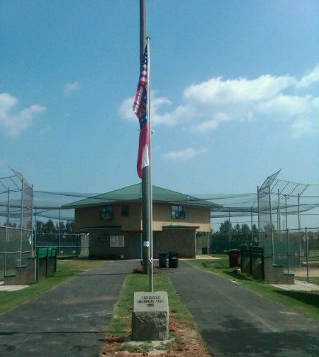

**Jasper County Recreation Department - providing quality recreations services for all Jasper County citizens.** The Jasper County Recreation Department is dedicated to creating positive experiences by providing quality programs for all our citizens. The goal of our youth athletic program is to offer a rich year-round schedule of athletic activities that encourage children to play a variety of sports, and to provide them with the opportunity to have fun while developing physically, emotionally and socially.

The Recreation Department strives to teach skills and sportsmanship through participation in the development of all youth and to teach the rules of play in each specific sport

For more information about the Jasper County Recreation Department click here…

Facebook link: <https://www.facebook.com/pg/jaspercorec/about/?ref=page_internal>

Website: <http://www.jaspercorec.com/>