**JASPER COUNTY**

**PRELIMINARY PLAT PETITION**

**Planning Commission**

**11/27/2023**

______________________________________________________________________________ **Case Number:** PPT23-002

**Name of Applicant:** Brian Cagle

**Address of Property:** 3535 County Line Road & Rocky Creek Rd

**Tax Parcel:** 008 005 & 008 005 001

**District:** 5 (Five) ______________________________________________________________________________ **Request:** To subdivide two contiguous parcels of land into 36 lots as a

Conservation Subdivision

**Applicable Standard:** Section 105-162 (Conservation Subdivision Design), Section 105-87 (Submission and approval of the preliminary plat), Section 105-3 (Purposes) of the Development Regulations; and Section 119-196 of the Zoning Ordinance

**Purpose of Request:** To create a conservation subdivision with 34 lots. Size of Property: 80.68 acres (shown as 85 acres on QPublic)

**Present Zoning:** RES (fka R1)

**Present Use:** Undeveloped

**Review Sections:** The applicable sections include Sec. 105-87, Sec. 105-3, Sec. 105- 162 and Sec. 105-222 of the Development Regulations and Sec. 119- 196 & Sec. 119-244 of the Zoning Ordinance. These sections are listed at the end of the report after maps & the applicant’s information.

**Staff Analysis, Comments & Recommendations:**

The tract of land is 80.68 acres designed as a Conservation Subdivision with a total of 36 lots

and 40.1% (32.39 acres) of greenspace. The property has road frontage on both County Line

Road and Rocky Creek Road (north end of the road). Rocky Creek Road is a local unpaved road

which requires improvement along the road frontage where it adjoins the existing property per

Sec. 105- 222 (a). The approximate amount of road frontage along Rocky Creek Road is

approximately 801.75+- feet

1

PPT23-002 – Twinpond Subdivision

Planning Commission 11/27/2023 & BOC 12/11/2023

The property was rezoned by the Jasper County Board of Commissioners on March 1, 2004 to

R2-15 zoning district which is now know as RES (Residential). The case number was 2004Z01

and below is the snippet from the official BOC Minutes:

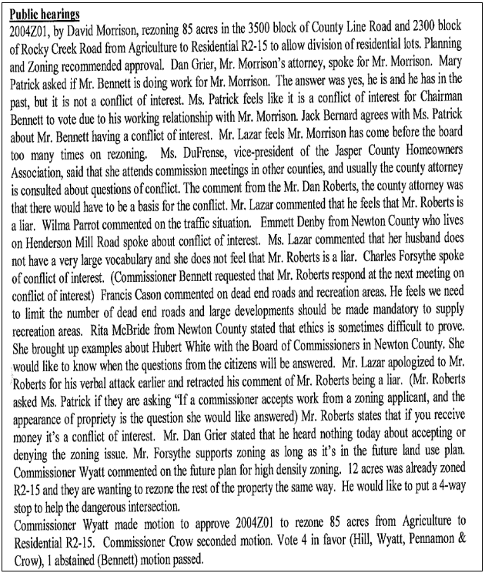

2

PPT23-002 – Twinpond Subdivision

Planning Commission 11/27/2023 & BOC 12/11/2023

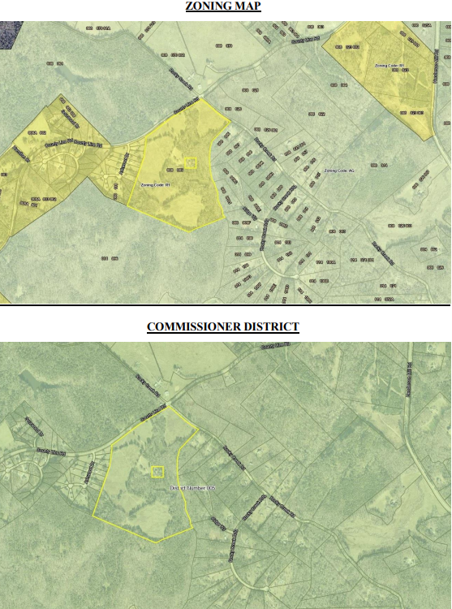

3

PPT23-002 – Twinpond Subdivision

Planning Commission 11/27/2023 & BOC 12/11/2023

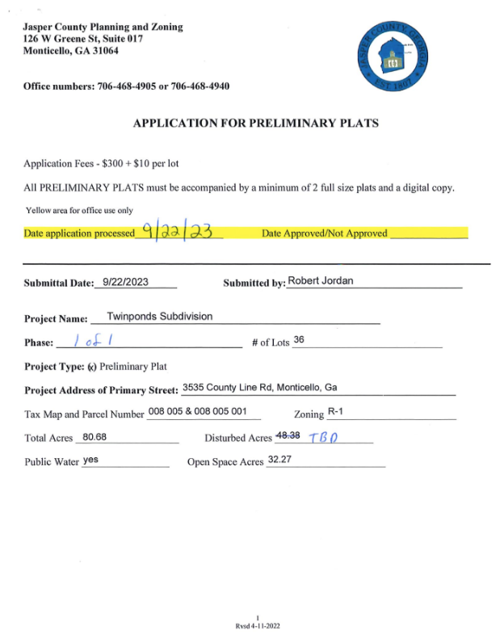

4

PPT23-002 – Twinpond Subdivision

Planning Commission 11/27/2023 & BOC 12/11/2023

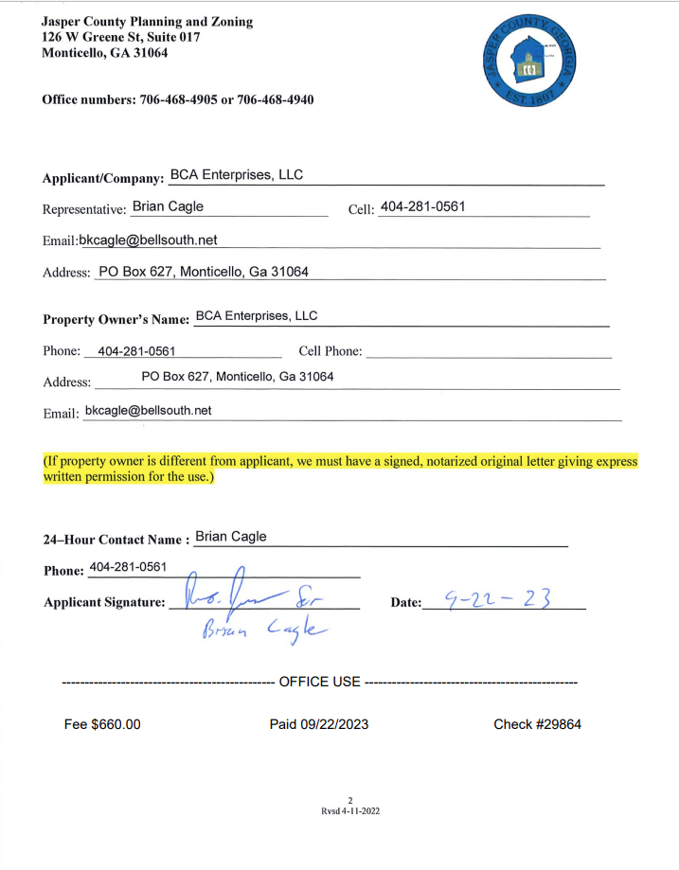

5

PPT23-002 – Twinpond Subdivision

Planning Commission 11/27/2023 & BOC 12/11/2023

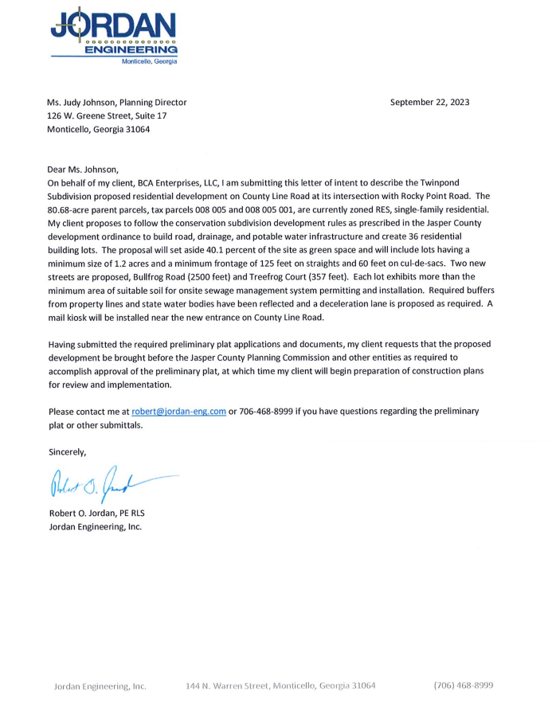

6

PPT23-002 – Twinpond Subdivision

Planning Commission 11/27/2023 & BOC 12/11/2023

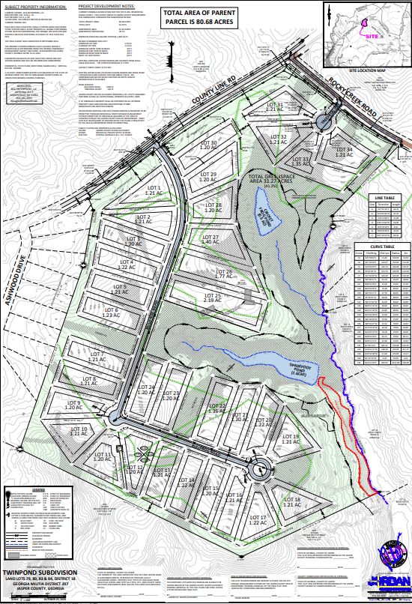

7

PPT23-002 – Twinpond Subdivision

Planning Commission 11/27/2023 & BOC 12/11/2023

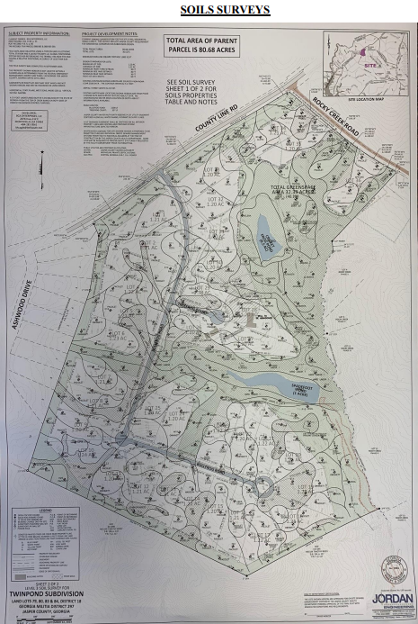

8

PPT23-002 – Twinpond Subdivision

Planning Commission 11/27/2023 & BOC 12/11/2023

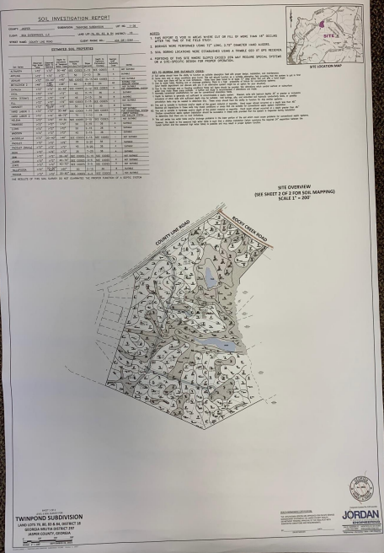

9

PPT23-002 – Twinpond Subdivision

Planning Commission 11/27/2023 & BOC 12/11/2023

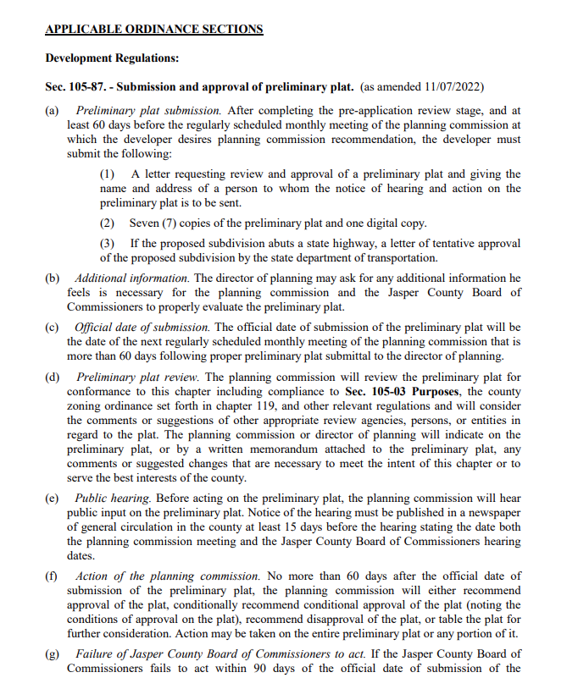

10

PPT23-002 – Twinpond Subdivision

Planning Commission 11/27/2023 & BOC 12/11/2023

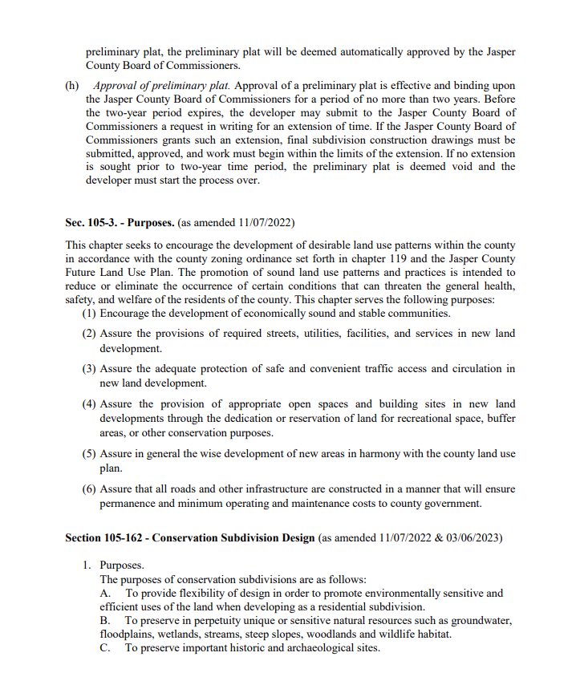

11

PPT23-002 – Twinpond Subdivision

Planning Commission 11/27/2023 & BOC 12/11/2023

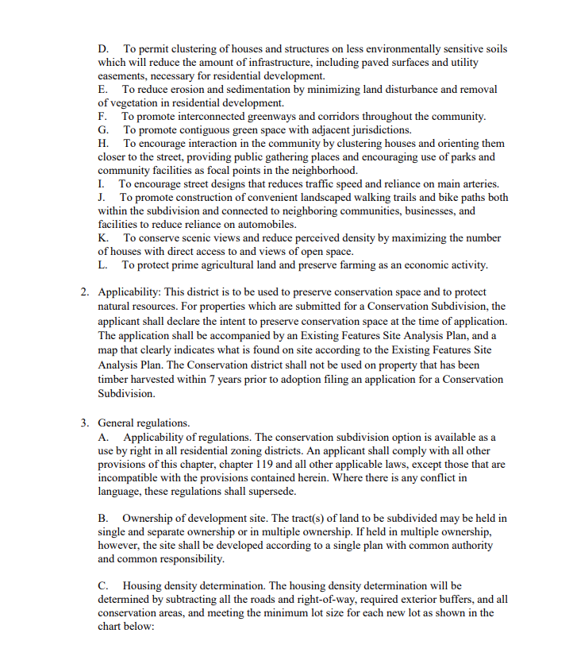

12

PPT23-002 – Twinpond Subdivision

Planning Commission 11/27/2023 & BOC 12/11/2023

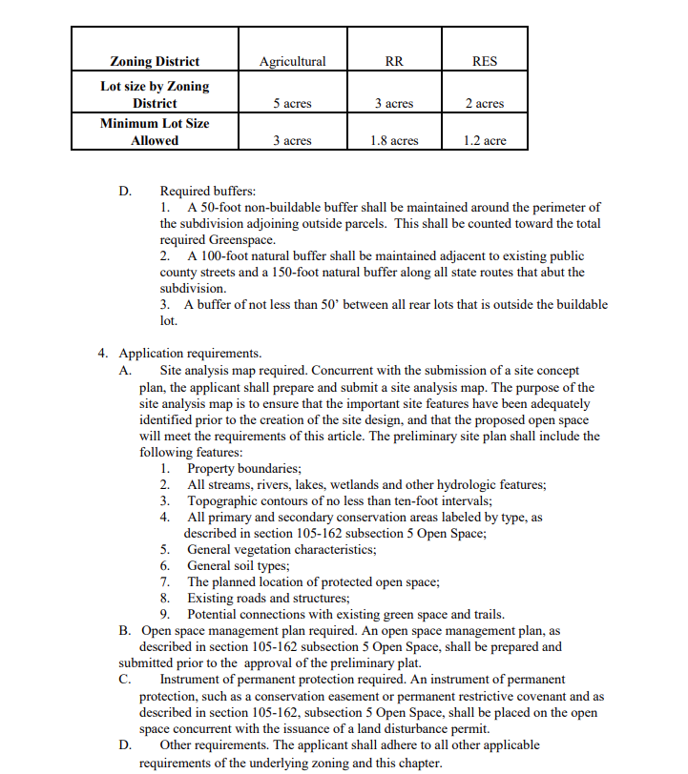

13

PPT23-002 – Twinpond Subdivision

Planning Commission 11/27/2023 & BOC 12/11/2023

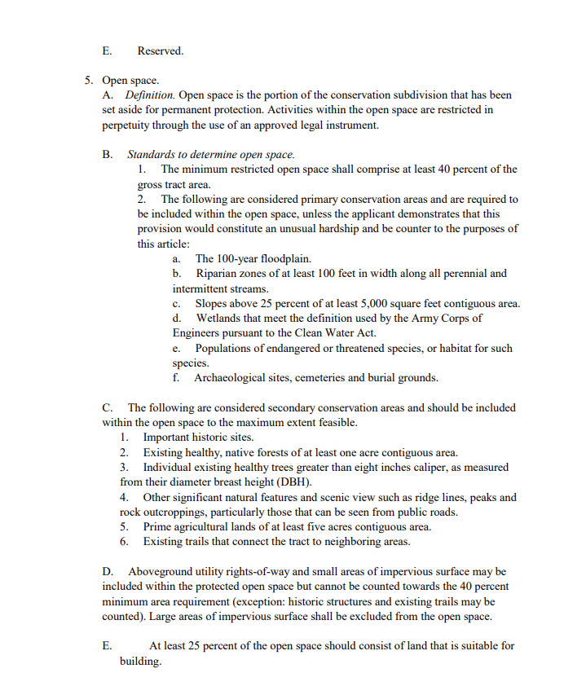

14

PPT23-002 – Twinpond Subdivision

Planning Commission 11/27/2023 & BOC 12/11/2023

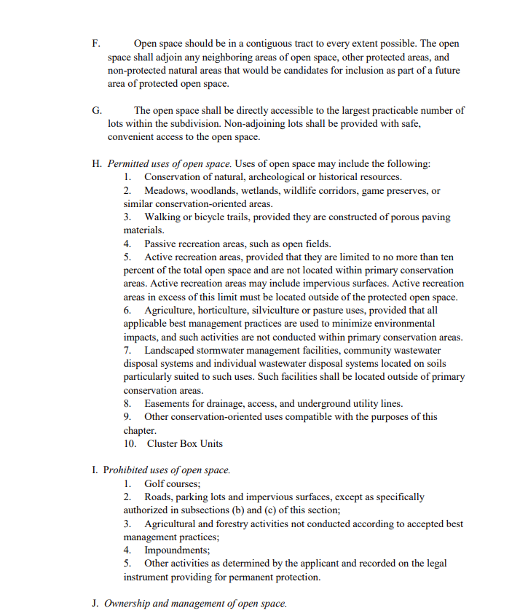

15

PPT23-002 – Twinpond Subdivision

Planning Commission 11/27/2023 & BOC 12/11/2023

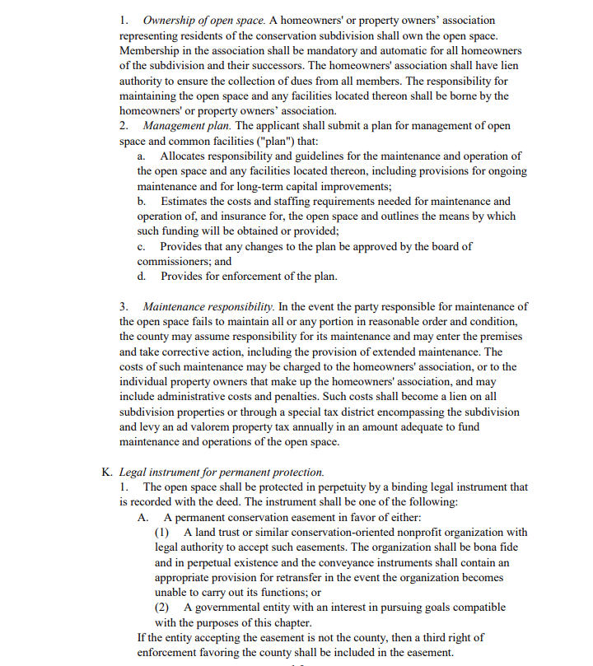

16

PPT23-002 – Twinpond Subdivision

Planning Commission 11/27/2023 & BOC 12/11/2023

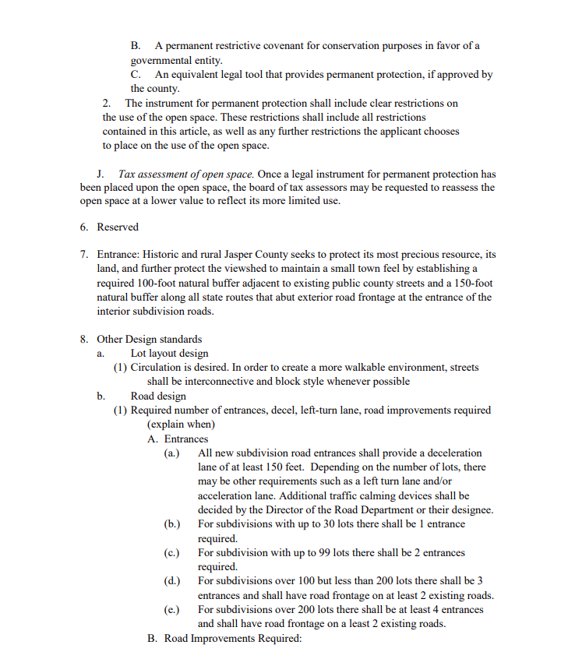

17

PPT23-002 – Twinpond Subdivision

Planning Commission 11/27/2023 & BOC 12/11/2023

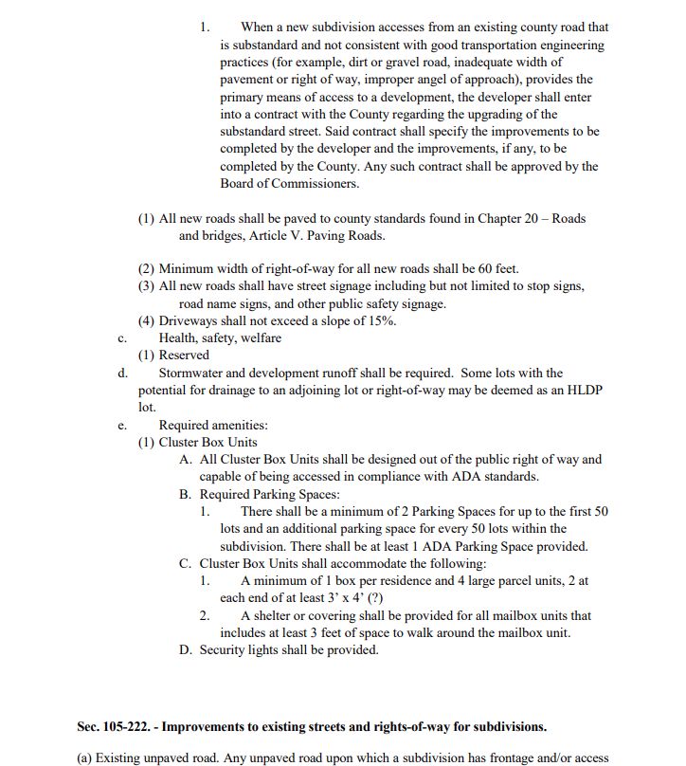

18

PPT23-002 – Twinpond Subdivision

Planning Commission 11/27/2023 & BOC 12/11/2023

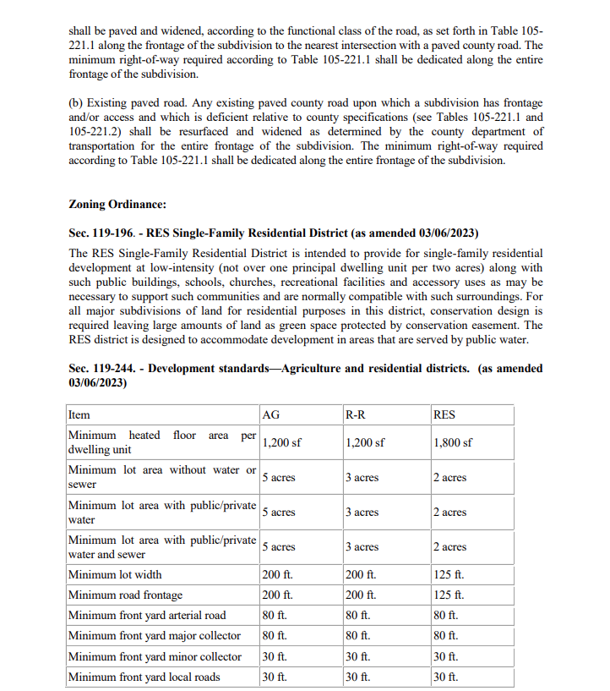

19

PPT23-002 – Twinpond Subdivision

Planning Commission 11/27/2023 & BOC 12/11/2023

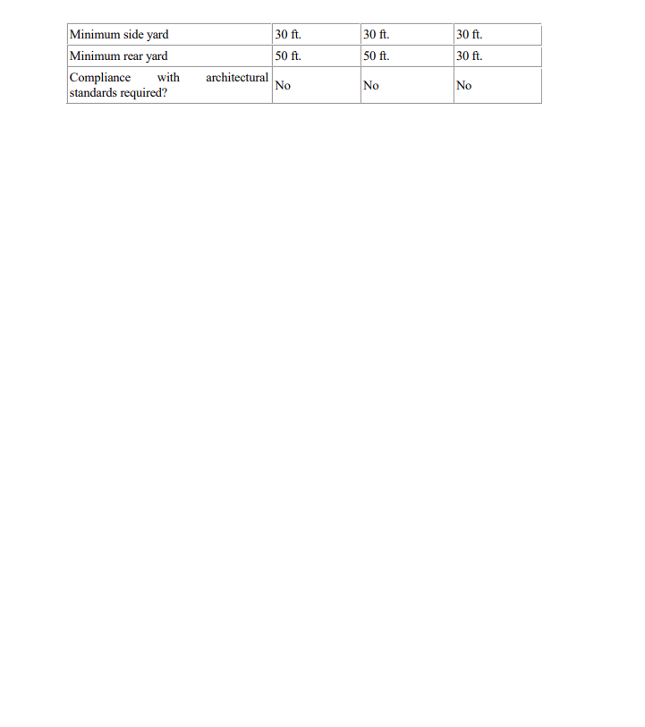

20

PPT23-002 – Twinpond Subdivision

Planning Commission 11/27/2023 & BOC 12/11/2023